

NATURE & ART COME TOGETHER\
Workshop Extension Series
with Artist & Illustrator, Devon Meyer

REGISTRATION FORM

Name ______________________________________

Mailing address _______________________________________ City_____________ Zip __________

Phone: _________________________

Email address: __________________________________

Full Workshop Extension Series includes 3 sessions, or choose individual classes. All supplies are included for each class.

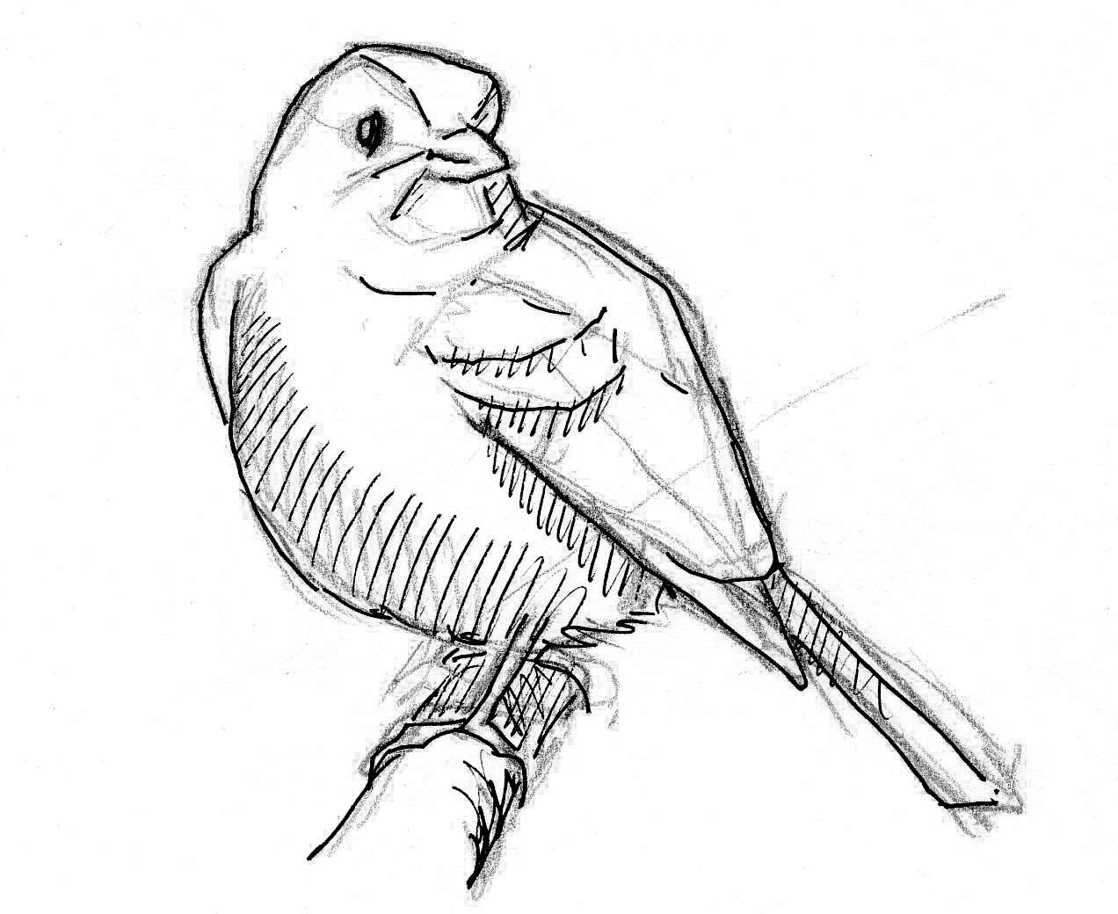
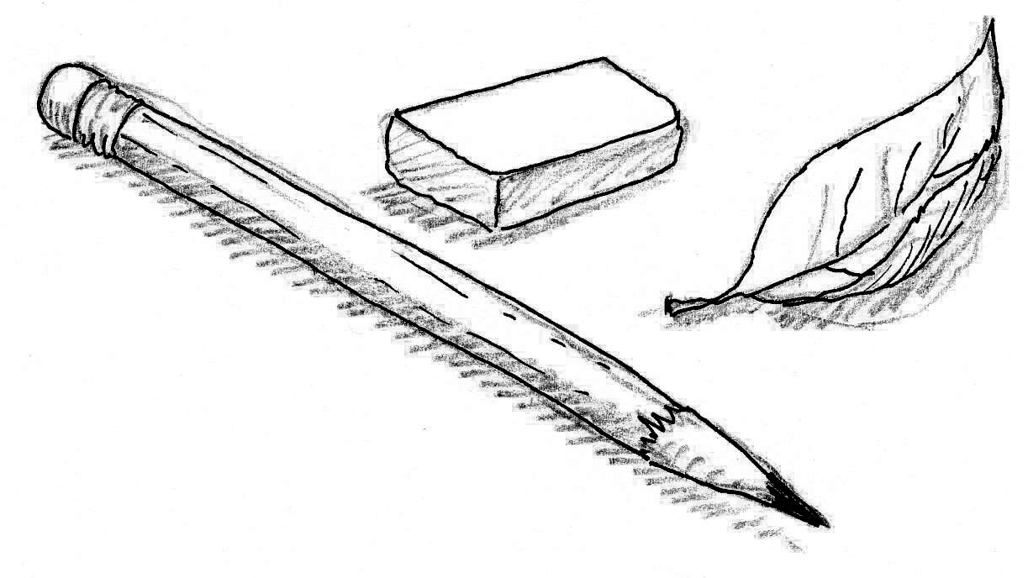
$38 per class (bring a friend and you both receive 10% off - must register together)

Saturday, March 7th
- Class 1 – Nature Journaling: Exploring plants and landscapes with color.

Saturday, April 18th
- Class 2 – Nature Journaling & Personal History: Exploring our place in the natural world through art.

Saturday, May 2nd
- Class 3 – Birds, Birds, Birds!: Discover birds through drawing and painting.

Sign up for the entire series for just $104 (10% discount!)

Check enclosed (made payable to “Audubon Arizona”)

Card #: _________________________________ Exp. Date:____________ CCV#_______________

Send completed registration forms to:
Audubon Arizona
ATT: Becky Gilbreath
3131 S. Central Ave.
Phoenix, AZ 85040

Questions contact: Becky Gilbreath, (602) 468-6470 x.101, bgilbreath@audubon.org

